**Task 1 - Managing simple widgets – Image, Button, Labels**

How to create a basic legato graphics project with MCC and Legato Graphics Composer will be covered.

Add images, labels, button widget (setting image pressed/released), position, size, set alpha level using schemes

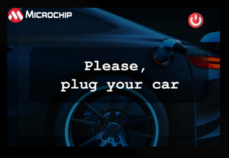 Screen 1

**Task 2– Managing Button events and screen transition**

Pressing Button transitioning to screen 2. Concept of multiple layers will also be introduced.

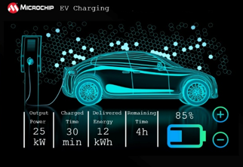 Screen 2

**Task 3 – Dynamic String & RTC**

Displaying Date/Time using RTC:

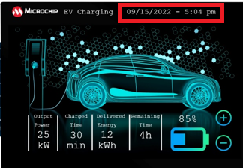

**Task 4- Animation Using Canvas**

4a. The charge cable will show animation using 2 methods:

1. Using Image Sequence Widget
2. Using Canvas and timer TC0 - “Screen 2 “ onShow event will start start TC0.

4b. On pressing button + / - button (button event), the battery level will change (animate).

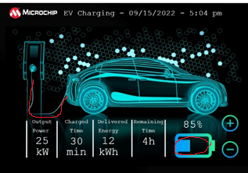

After 5 seconds (timeout event) the following screen will show with battery level animation:

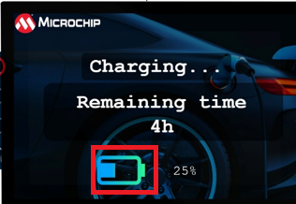*** if less than 100% charge required show with dotted line

After 10 seconds (timeout event) following will show:

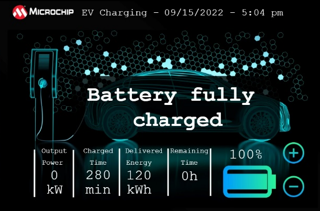

**Task 5: Event Filter**

From the “Battery Fully Charged” screen, a swipe from top to bottom of the screen will show an info box which will disappear after 5 s.

BONUS TASK: instead of doing screen switch, create a screen of size 480 x160 and using canvas, move screen for button event.

**Topics Covered:**

1. Buttons, labels, images, image sequence widget, schemes
2. Multi layers
3. Button events and screen transitions, screen (OnShow) events
4. Timers & RTC
5. Dynamic Strings
6. Canvas Animation and sprite